

School of Education, Social Work &
Community Education

Applied Computing

Year of Programme: | 2011 | Academic Session: |  | Semester One
Module: | Algorithms and Artificial Intelligence – AC21007
Assignment Title: | Coursework 4 – Symbolic AI
Matric. Number: | 110009870

Word Count: | Date Submitted:  11/11/11 | Extn Agreed:  (check if applicable) | Resubmission:

……………………………………………………………………………

OFFICE USE ONLY

Date Received: |  | Time Received (if late):

Is the work:

Overlength
Underlength
Late
Incomplete
Non-Anonymised

AC21007 - Algorithms and Artificial Intelligence – Symbolic AI

Lucas Tower Puzzle - Graph Search

Description of problem:
The Lucas Tower Puzzle (also known as the Tower of Brahma/Hanoi puzzle) is a mathematical game or puzzle. It consists of three rods identified by characters A, B and C, and a number of disks of different sizes which can slide onto any rod. In this case it will be 3 disks identified by size numerically with 1 being the smallest and 3 being the largest. The puzzle starts with the disks in a neat stack in ascending order of size on the left rod, the smallest at the top, thus making a conical shape. The goal is to move all discs from the left peg to the right peg using the smallest number of possible moves.
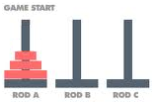
Only one disc may be moved at a time and a disc can be placed either on an empty peg or on top of a larger disc, no disk is allowed to be placed on top of a smaller disk. The smallest number of moves is calculated by 2^{n-}1 to get the least amount of moves to complete the game.
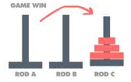
The puzzle is frequently used in psychological research on problem solving and as a test by neuropsychologists to evaluate frontal lobe deficits. In the film “Rise of the Planet of the Apes” (2011) the puzzle was used as a test for intelligence in apes that suffered from frontal lobe deficits under the name "Lucas Tower".

There is also a legend about an Indian temple which contains a large room with three time-worn posts in it surrounded by 64 golden disks. Brahmin priests, acting out the command of an ancient prophecy, have been moving these disks, in accordance with the rules of the puzzle, since that time. According to the legend, when the last move of the puzzle is completed, the world will end. It is not clear whether Édouard Lucas the French mathematician in which the puzzle is named after invented this legend or was inspired by it. (Wikipedia http://en.wikipedia.org/wiki/Tower_of_Hanoi 2011)

If the legend were true, and if the priests were able to move disks at a rate of one per second, using the smallest number of moves, it would take them 2⁶⁴−1 seconds or roughly 585 billion years using 18,446,744,073,709,551,615 turns to finish it. Using the same rate of 1 move per second, the puzzle using 3 discs can be solved in 8 seconds with 8 turns, considerably shorter than 585 billion years.

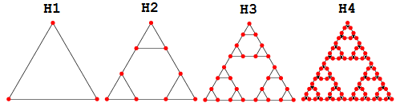
A graph H^{n} corresponding to the allowed moves in the tower of Hanoi problem. The above figure shows the Hanoi graphs for small n. The Hanoi graph H^{n} can be constructed by taking the vertices to be the odd binomial coefficients of Pascal's triangle computed on the integers from 0 to 2^{n-}1 and drawing an edge whenever coefficients are adjacent diagonally or horizontally (Pool 1994). The graph H^{n} has 3^{n}vertices and 3(3^{n}-1)/2 edges. Each Hanoi graph has a unique Hamiltonian cycle of which is NP-complete.

Screenshot of Solution using A* search algorithm:
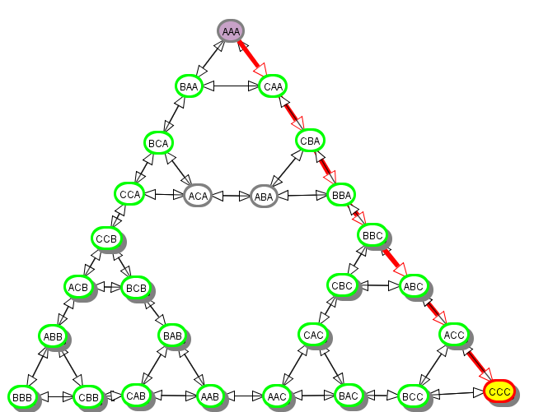

Description of Solution method:
During the initial runs of the puzzle I found that each algorithm produced the same results as both BBB and CCC were goal nodes. The way in which I viewed the problem was that the 3 discs could be moved left or right to reach the goal node represented by BBB or CCC. However the search graph produced the same results regardless of which algorithm was used. The problem was that the game could only reach an end state when all three discs had been moved from peg A to peg C. Regardless if they moved left or right another state needed to be represented to show the state of peg B. Even though three discs could be placed on Peg B at one time, this was not an end goal state so I replace the BBB goal node with a regular node allowing different search results to be generated using different algorithms whilst also satisfying the rules of the puzzle.

The best search algorithm was A*, however breadth first worked equally as well. The reason for choosing A* over breadth first (even though they produced the same time and space complexity in this example) is that A* is a complete algorithm and it will find the optimal route, whereas breath-first only finds a solution if b if finite and its only optimal if all costs are identical. Both algorithms work equally well and produced the same results however A* was my preference and allows for costs to be different if needed.
Other algorithms such as depth first produced paths with lower time complexities but higher space complexity’s and because of this they were not optimal routes. To produce the most optimal route more time was required to produce a lower cost path and the algorithms were not complete.

To traverse the nodes I had to enable loop detection that would ensure AI space did not get stuck in an infinite loop. Enabling this allows for algorithms to be used that would otherwise infinitively loop in circles. Due to the nature of the puzzle it is entirely possible to return to the original state of the game and from any point, getting caught in a loop that was reversing the moves would cause the puzzle to continue indefinitely.
Dinning philosophers – CSP

Description of problem:
The problem of the dining philosophers is set in a secluded community of five philosophers. The philosophers engage in only two activities – thinking and eating. As the five silent philosophers sit at a table around a bowl of spaghetti that is endlessly replenished with an unlimited supply, 5 forks are placed on the table with 1 fork between each pair of adjacent philosophers. Unfortunately, the spaghetti is hopelessly tangled and a philosopher needs two forks in order to eat. As the philosophers will not speak to each other they will only take a fork if the fork is free on the table and each fork must be taken independently one at a time. A fork cannot be shared by 2 philosophers at any time.
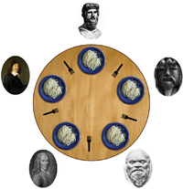
The dinning philosophers is used to illustrate various problems that can occur when competing for limited resources. The original problem was related to external devices like tape drives, however, the problems in the Dining philosopher’s problem arise far more often when multiple processes access sets of data that are being updated. This problem interested me because of the applications of resource sharing both in the real world and in computer hardware alongside appearing to be a recurring problem that is mentioned in various course modules.

Screenshot of Solution:
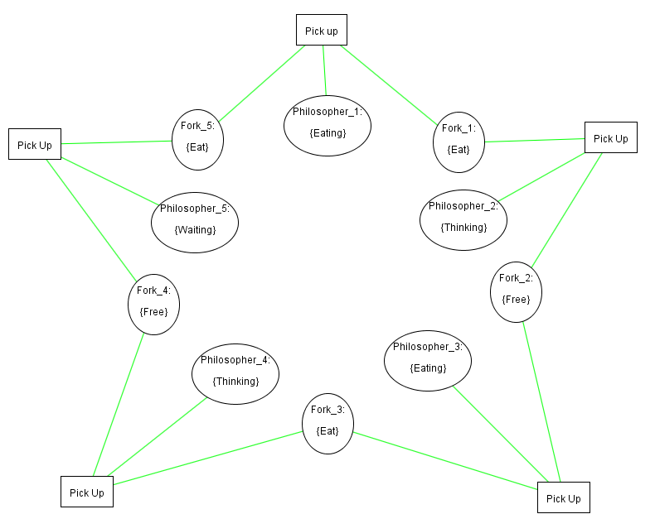

Description of Solution method:
The solution to the problem is to allow 2 philosophers to eat whilst the other 3 philosophers think, with one of the thinking philosophers taking the last fork and hold it whilst thinking. As there is an odd number of forks one philosopher will hold a fork until the next iteration in which case the fork to his right will become free. When the philosopher with the fork takes the opposite fork and now has 2 forks, it causes the philosopher eating in the previous iteration to no longer have access to both forks and requires him to start thinking. This allows for alternating between eating and thinking. I represented the thinking philosopher with the fork in my CSP as a waiting philosopher, for all intendeds and purposes; this is simply another thinking philosopher but can be uniquely identified easily from other philosophers thinking.

Iterations | Philosopher 5 | Philosopher 4 | Philosopher 3 | Philosopher 2 | Philosopher 1
1 | Waiting | Eating | Thinking | Eating | Thinking
2 | Thinking | Waiting | Eating | Thinking | Eating
3 | Eating | Thinking | Waiting | Eating | Thinking
4 | Thinking | Eating | Thinking | Waiting | Eating
5 | Eating | Thinking | Eating | Thinking | Waiting

Each philosopher will take a turn to pick up a fork to his right (if free) followed by the fork to his left (if free). If he is holding 2 forks he can then eat and the forks are no longer free for the next philosopher to pick up. The next philosopher will attempt to pick up the fork to his right and left however as the fork to his right is being used by the previous philosopher he cannot eat and commences thinking leaving the left fork free for the next philosopher. This will continue until the nth philosopher in which case only 1 fork is free to his right. When the nth philosopher’s fork to his right is free but the fork to his left is being eaten with then he cannot eat however he can pick up the fork to his right and hold it whilst thinking. During the next iteration when the philosophers finish eating they set down their forks and as the nth philosopher is still holding his, he can pick up the fork to his left and begin eating. During each iteration the person holding the single fork is always the nth philosopher -1 (n-1). When n=0 then n=6, so (n-1) gives the 5th philosopher and decrements down until philosopher 1 is reached again. This allows all philosophers to alternate between eating and thinking until the infinite supply of spaghetti runs out.

A problem that I encountered was that philosophers could starve to death via deadlock.
If each philosopher picks up a forks as soon as it is available and waits indefinitely for the other, eventually they will all end up holding only one fork with no chance of acquiring another as each fork must be put down one by one. The solution is to implement a discipline of behaviour so each philosopher can alternate between eating and thinking such no individual should die of starvation. This is why in my solution I implemented a behaviour of each philosopher taking a turn to pick up both forks to eat one by one and setting the forks back down in that turn if they only have access to the fork to their right.

Definite Clause definition
Description of problem:
The problem that I will be solving is a robot navigation problem modelled on a knowledge base used by Shakey in his experimental environment consisting of doors, walls, objects and himself. Shakeys movements are directly controlled by a set of low level action programs. These low level actions provide some of the building blocks for more complicated programs called intermediate level actions. For intermediate level actions to work they need information about Shakey experimental environment, Shakey models his environment with a list of assertions giving him information about the locations of walls, doorways, other objects and himself. Each of these will be part of the knowledge base and low level actions will be created using this knowledge base and from these low level actions, intermediate level actions will be created.

After Shakey computes a route he traverses it to the goal one step at a time. Although the real Shakey plans his entire route then executes this to do this in the AI space would prove to be far too complex. In the diagram below it can be seen the starting position of Shakey is in room 1. The goal is to get Shakey into room 6 with the object 1 from room 5. To do this Shakey has to move from room 1 through door way 1 to room 2, followed by doorway 5 to room 5 and then push box 1 from room 5 to room 6 by going through doorway 6 into room 6. Shakey will also check that the object is in the correct room and that he is in the correct room before traversing to the next node.

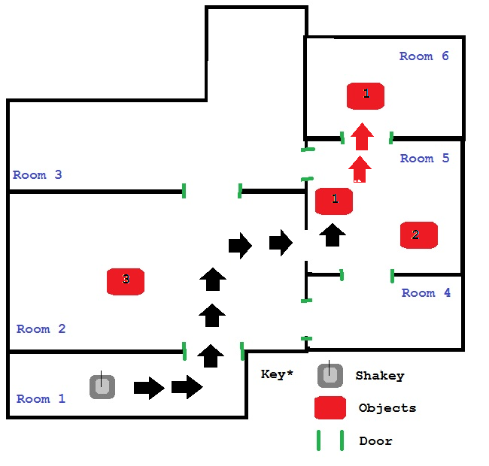
Description of Solution method:
The query that I used to traverse the nodes from room 1 to room 6 whilst pushing the box from room 5 to room 6 is the following three functions that were intermediate level actions which when combined produced the solution seen in the diagram above.

- Shakey.Route(room_1,door_1,room_2)
- Shakey.Route(room_2,door_4,room_5)
- Shakey.PushObject(room_5,object_1,door_5,room_6)

Heuristic depth first is the best algorithm. In comparison to depth first it produces the same results however depth first does not produce the optimal path. Heuristic depth first will produce the optimal path if the unit step cost is the same. The other algorithms did not complete within 50 steps so they were not considered as they did not produce results.
A problem that I encountered was during the creation of intermediate level actions. As these were created from low level actions, functions had to be created to uses the lower level actions to create the intermediate level actions. For example: Shakey. Route() takes 3 parameters, the room it’s currently in, the door it’s trying to go through and the room it is trying to access. This is made up of low level actions such as which room is Shakey in , which room Shakey is trying to go to, which door way Shakey is trying to go through to get to the room, Shakey moving to the room and finally Shakey being in that room. This required the knowledge base to be expanded to check acceptable parameters for Shakey to use in his route. If Shakey was trying to access room 6 by going through the wrong doorway it would produce a false route which Shakey could not follow, thus requiring it to step back and find a new route or use an acceptable doorway to access the room.

Screenshot of Solution:
